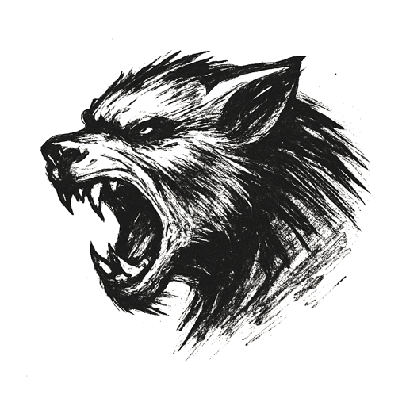
A phone screen glowed in the dark, its light dancing across posters of pop stars on a pale bedroom wall. A stuffed bear slumped by her pillow, one ear worn thin.
Notifications popped like fireworks: names she knew, faces she trusted, each message sharper than the last.
A rumor spread — a lie born in shadows, shared with laughs, amplified by strangers.
Her room felt smaller with each buzz. Breath came shallow, eyes rimmed in salt. Fingers scrolled, desperate for one voice to say it wasn’t true. Only more jeers, more shares.
Outside, the world moved on. Inside, she saw no world at all.

A fractured basket. A monster inside.

